Auma India

Functional Requirements

This document specifies deliverables and functional requirements for the Auma India App (the app).

# Revision History

|  |  |  |
| --- | --- | --- |
| Date | Version | Description of Revision |
| 29/06/2019 | 01.00 | Initial document creation |
| 01/07/2019 | 02.00 | Changes in the App flow |
|  |  |  |
|  |  |  |
|  |  |  |
|  |  |  |
|  |  |  |
|  |  |  |
|  |  |  |

Contents

Revision History 1

Date 1

Version 1

Description of Revision 1

Specification Details 2

Section 1: Splash screen 2

Section 2: Login screen 3

Section 3: Device Scanning Screen 4

Section 4: Devices screen 5

Section 5: Main / Dashboard screen 6

Section 6: Read parameter screen 7

Section 7: Read event screen 8

Section 8: Write parameter screen 9

Section 9: Write sub-parameter screen 10

Section 10: Write sub-parameter value change screen 11

Section 11: RTC 11

# Specification Details

## Section 1: Splash screen

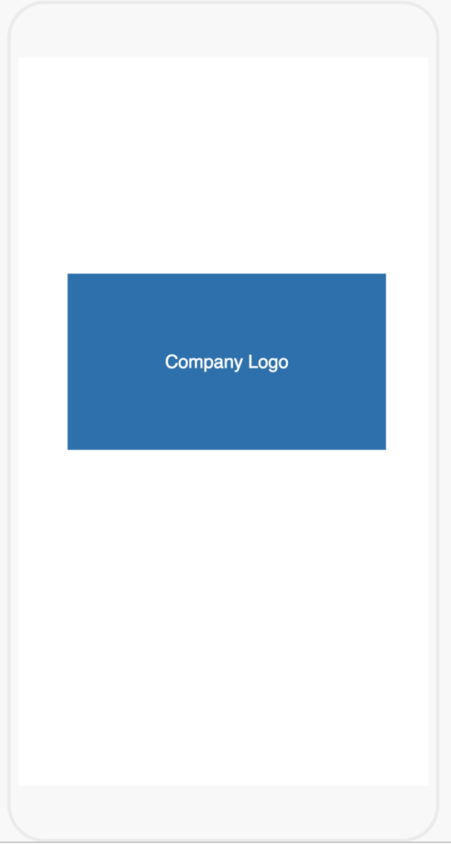

1. displays logo and title as specified by client (TBD)
   1. displays immediately upon start of the app
      1. remains visible until app is fully loaded, at which time it is:
      2. replaced by default screen (see Section 2)

## 2

1. automatically after few seconds from the splash screen
   * 1. device scanning screen (section 3)

## Section 3: Device Scanning Screen

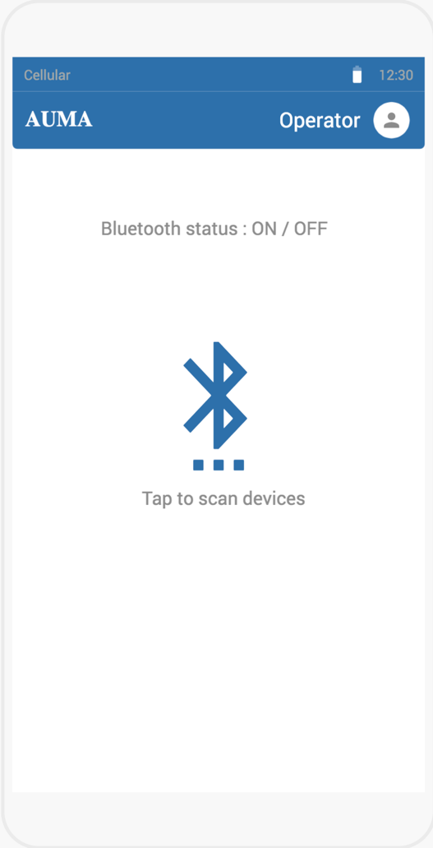

1. Modal displays device scanning screen.
   1. It shows the Bluetooth status (ON / OFF)
   2. It will display what kind of user has logged in near to the user icon in the top right corner
   3. User has the option to logout by tapping user icon in the top right corner, which will be redirected to login screen (section 2)
   4. Upon tapping the Bluetooth icon
      1. If status = OFF, user will be prompted message to turn on the Bluetooth from the phone settings
      2. If status = ON, user will be redirected to list of available devices screen (section 4)

## Section 4: Devices screen

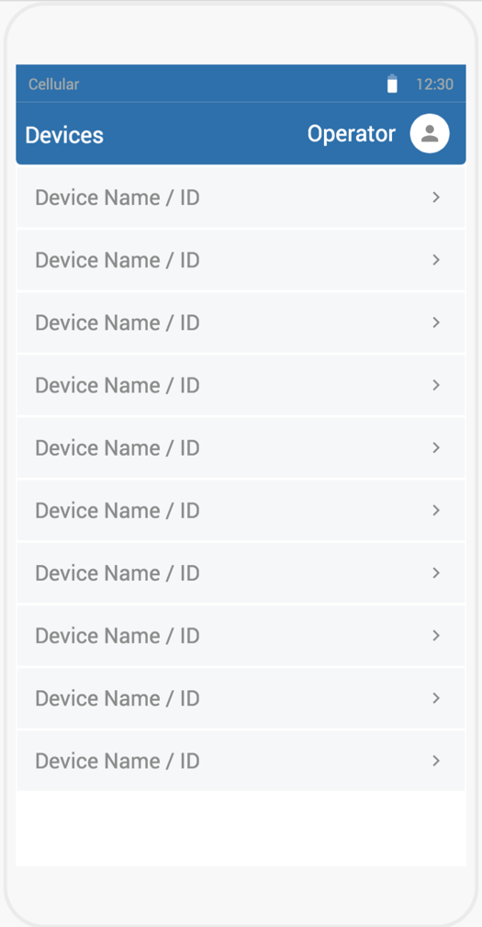

1. Modal displays all available devices
   1. By tapping any of the device from the list, it will be paired, and screen will be redirected to Main menu (dashboard) screen (section 5)
   2. It will display what kind of user has logged in near to the user icon in the top right corner
   3. User has the option to logout by tapping user icon in the top right corner, which will be redirected to login screen (section 2)

## Section 5: Main / Dashboard screen

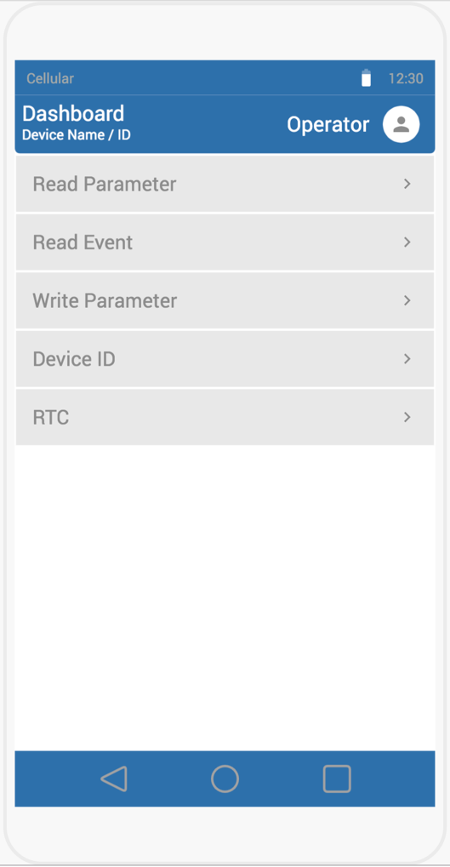

1. Modal displays the below items
   1. It will display what kind of user has logged in near to the user icon in the top right corner
   2. User has the option to logout by tapping user icon in the top right corner, which will be redirected to login screen (section 2)
   3. Read Parameter
      1. Once the user taps the “Read Parameter”, all the parameter values are read (section 6) from the Bluetooth device along with device ID and will be stored in the local database. It will also automatically redirect to write parameter screen (section 8)
      2. If the paired device parameters are existing, the values will be replaced
      3. If the paired device parameter doesn’t exist, all the values will be added with the corresponding device ID
      4. User has option to cancel from reading parameter. Upon cancel, data will not be saved, and user will be taken back to the main/dashboard screen
   4. Read Event
      1. Once the user taps the “Read Event”, all the event values are read (section 7) from the Bluetooth device along with device ID, will be written to the file in the excel format and stored in the device memory
      2. Once the events are read, what action?? TBD
      3. User has option to cancel from reading event. Upon cancel, data will not be saved, and user will be taken back to the main/dashboard screen
   5. Write Parameter
      1. Once the user taps the “Write Parameter”, it will be redirected to the list of main parameter screen (section 8)
      2. Write parameters menus are restricted as per the user type
   6. Device ID
      1. Once the user taps the “Device ID”, it will be redirected to the screen to change the device ID (section 9)

## Section 6: Read parameter screen

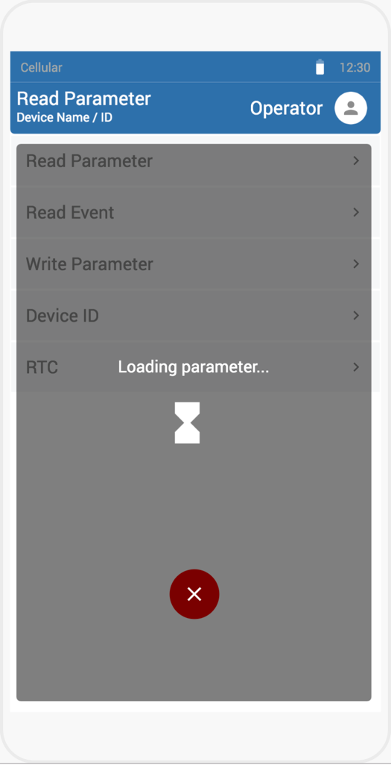

1. User has opened Read Parameter screen
   1. It keeps reading ALL the parameter values with the progress
   2. User has option to cancel from reading the parameter. Once cancel button is tapped, data will not be saved, and user will be taken back to the main / dashboard screen (section 5)
   3. Once All the values are read, data will be either replaced by the existing data for the specific device ID or created new record and will be redirected to the write parameter screen (section 8)

## Section 7: Read event screen

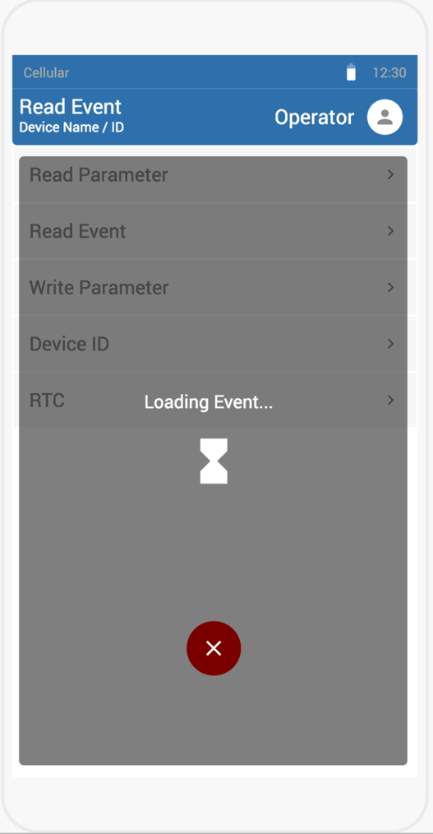

1. User has opened Read Event screen
   1. It keeps reading ALL the event values with the progress
   2. User has option to cancel from reading the event. Once cancel button is tapped, data will not be saved, and user will be taken back to the main / dashboard screen (section 5)
   3. Once All the values are read, data will be written to the file in excel format and will be stored in the phone memory (local storage)
   4. Is there any specific action to be done after reading the events?

## Section 8: Write parameter screen

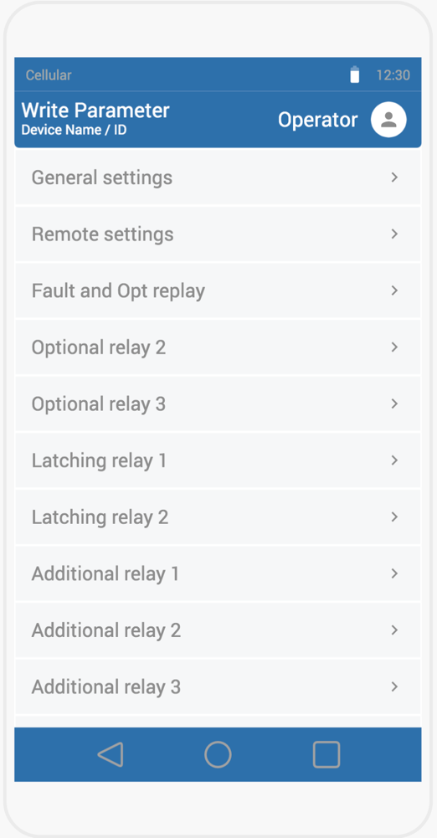

1. User has opened Write Parameter screen or automatically redirected after reading all the parameters from the read parameter screen (section 6)
   1. It displays list of main/parent write parameters as provided by the client.
   2. Write parameter menus are restricted as per the user type
   3. Once the user taps any of the item, it will be redirected to the sub parameter screen (section 9 – This section displays the sub parameters of “General Settings”. Likewise, the screen will list out the sub parameter for each main parameter. For demo/prototype purpose, only “General Settings” sub parameters are shown)
   4. User can go back to the main/dashboard screen (section 5) by tapping phone’s physical back button

## Section 9: Write sub-parameter screen

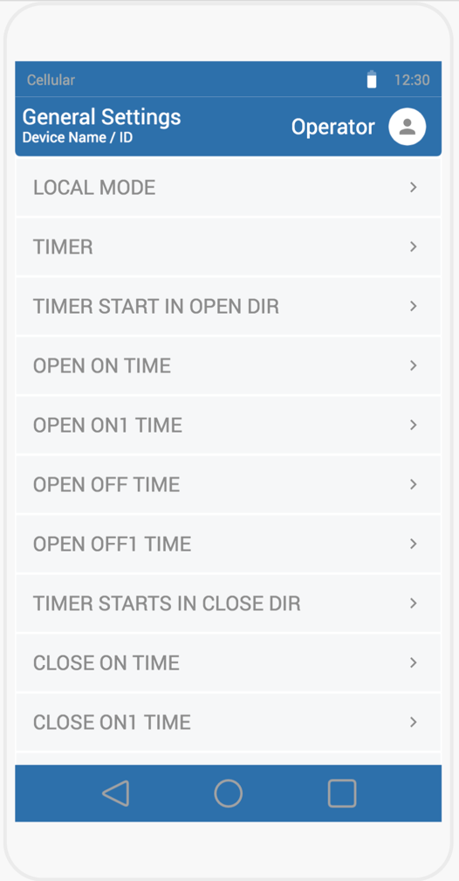

1. User has opened Write sub-parameter screen
   1. All the sub parameter names are displayed in this screen (In this case “General Settings” sub parameter is displayed for prototype/demo purpose)
   2. Once the user taps any of the sub parameter, it will be redirected to the screen where user can change the values (section 10)
   3. User can also go back to the main parameter screen (section 8) by tapping phone’s physical back button

## Section 10: Write sub-parameter value change screen

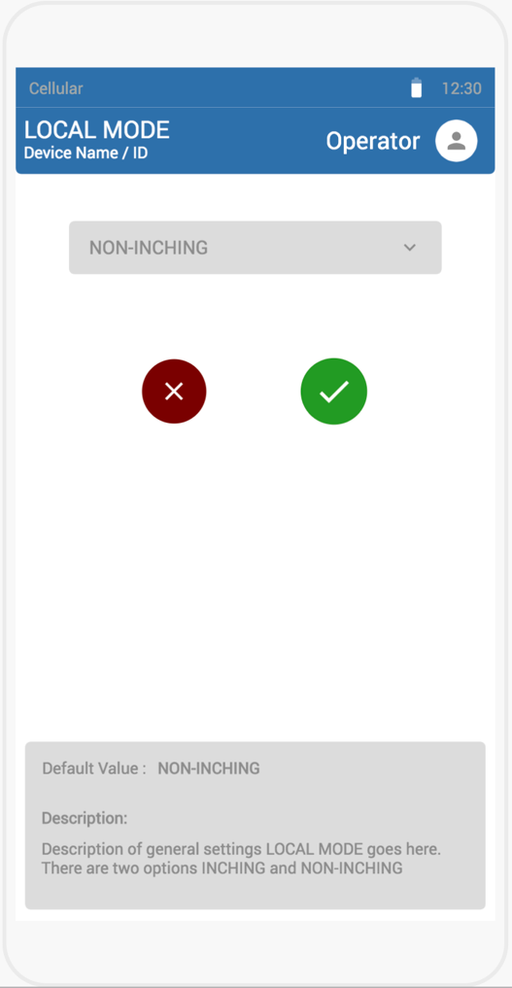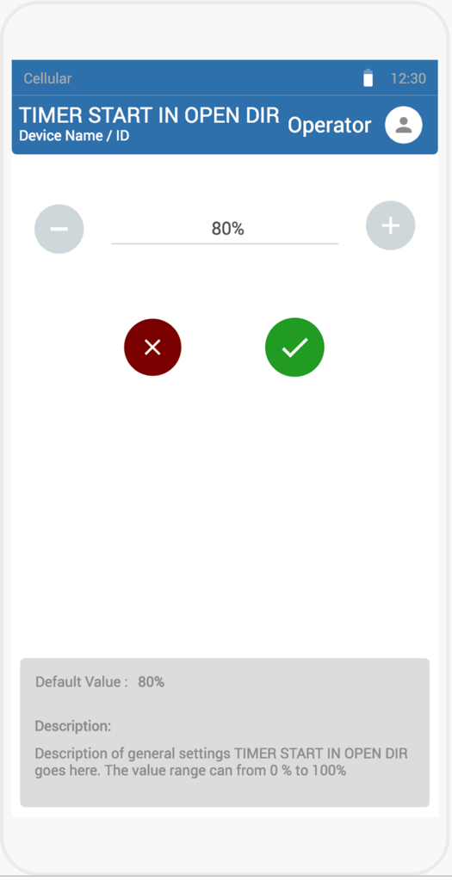

1. User has opened write sub-parameter value change screen
   1. User can change the value by tapping the edit button in the right top corner
   2. If a user is already signed in, then all the fields are enabled to make changes
   3. If a user is not signed in, it will redirect to the login screen (section 3)
   4. Once the user is authenticated, user will be able to make changes.
   5. This screen displays the default and other information about the parameter in the bottom
   6. By tapping the “tick” button, all the data will be saved locally, written to the Bluetooth device and redirects to the (section 9) screen
   7. By tapping the “cancel” button, it will be redirected to the (section 9) screen

Section 11: RTC

1. User will be able to set the real time clock to the Bluetooth device by tapping the “RTC” menu option from the dashboard screen (Section 5)